**Project Design Phase-II**

**Data Flow Diagram & User Stories**

|  |  |
| --- | --- |
| Date | 15 October 2022 |
| Team ID | PNT2022TMID42792 |
| Project Name | SMART SOLUTION FOR RAILWAYS |
| Maximum Marks | 4 Marks |

# Data Flow Diagrams:

A Data Flow Diagram (DFD) is a traditional visual representation of the information flows within a system. A neat and clear DFD can depict the right amount of the system requirement graphically. It shows how data enters and leaves the system, what changes the information, and where data is stored.

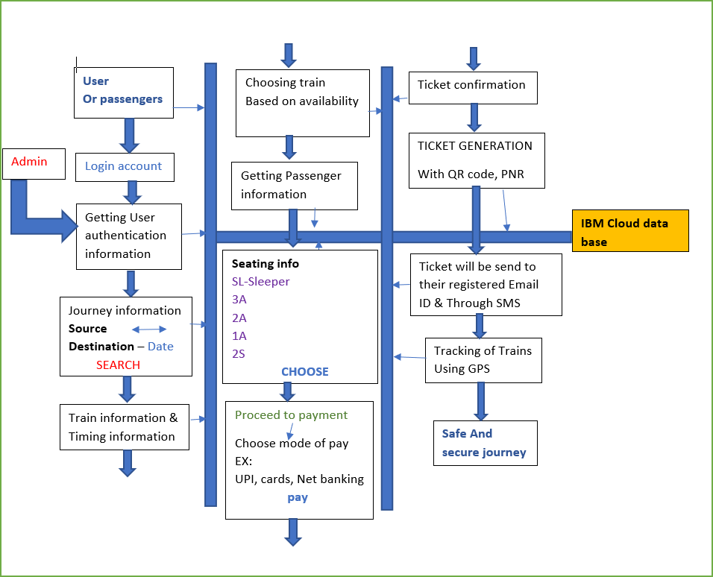

**DATA FLOW DIAGRAM**

# User Stories

Use the below template to list all the user stories for the product.

| **User Type** | **Functional Requirement (Epic)** | **User Story Number** | **User Story / Task** | **Acceptance criteria** | **Priority** | **Release** |
| --- | --- | --- | --- | --- | --- | --- |
| Customer (Mobile user) | Reserving ticket | USN-1 | As a user, I can register for the application by entering my email, password, and confirming my password. | I can access my account / dashboard | High | Sprint-1 |
| Customer (Mobile user) | Reserving ticket | USN-2 | As a user, I will receive confirmation email once I have registered for the application | I can receive confirmation email & click confirm | High | Sprint-1 |
| Customer (Mobile user) | Reserving ticket | USN-3 | As a user, I can register for the application and enter the details for reserving the ticket | I can register & access the dashboard with Facebook Login | Low | Sprint-2 |
| Customer (Mobile user) | Dashboard | Users | The details will be stored safely | I can access it using database | Medium | Sprint-1 |
| Customer  (Web user) | Reserving ticket | User | Enter the details and click submit button to book tickets | I can use the QR code which is been generated | High | Sprint-1 |
| Customer Care Executive | Connecting the service provider | Customer | Connects with the service by logging in | Can get connected with the server | Medium | Sprint-3 |
| Administrator | Provides the services | Admin | The data is given by the user | Can add or update the data provided by the user | High | Sprint-1 |